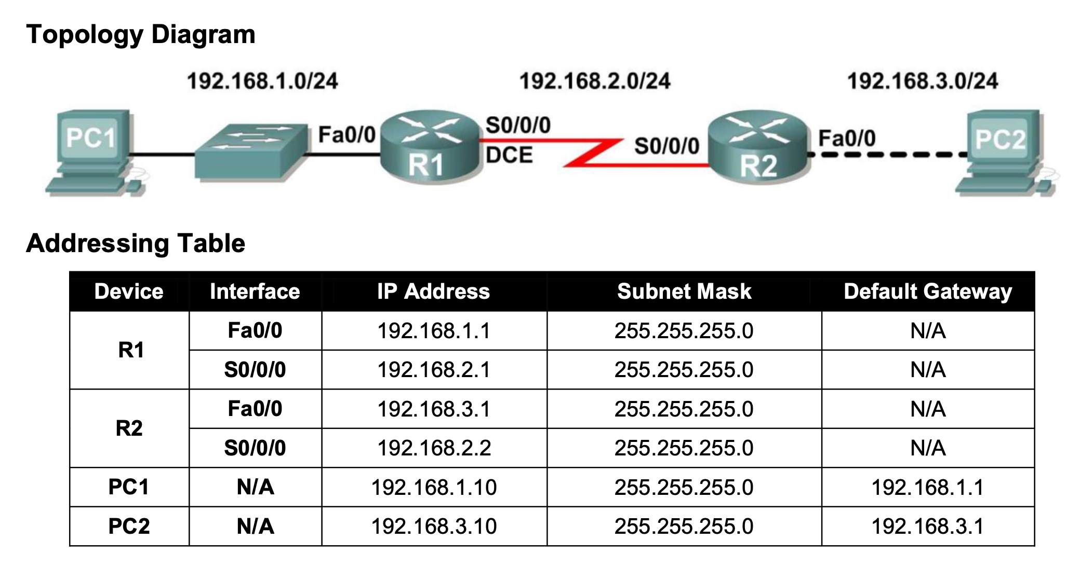

Cables required

Copper cross over cable ------------------

Copper straight Through ____________

Serial DTE / Serial DTC

R1 Commands

Router>en

Router#config t

Enter configuration commands, one per line. End with CNTL/Z.

Router(config)#hostname R1

R1(config)#line console 0

R1(config-line)#password cisco

R1(config-line)#login

R1(config-line)#exit

R1(config)#line vty 0 4

R1(config-line)#password cisco

R1(config-line)#login

R1(config-line)#exit

R1(config)#interface FastEthernet0/0

R1(config-if)#ip address 192.168.1.1 255.255.255.0

R1(config-if)#exit

R1(config)#interface Serial0/0/0

R1(config-if)#ip address 192.168.2.1 255.255.255.0

R1(config-if)#no sh

R1(config-if)#description R2 LAN

R1(config-if)#end

R1#copy running-config startup-config

R1#show running-config

R1# show interfaces fastEthernet 0/0

R1#show version

R1#show ip interface brief

____________

R2 Commands

Router>en

Router#config t

Enter configuration commands, one per line. End with CNTL/Z.

Router(config)#hostname R2

R2(config)#line console 0

R2(config-line)#password cisco

R2(config-line)#login

R2(config-line)#exit

R2(config)#line vty 0 4

R2(config-line)#password cisco

R2(config-line)#login

R2(config-line)#exit

R2(config)#interface FastEthernet0/0

R2(config-if)#ip address 192.168.3.1 255.255.255.0

R2(config-if)#exit

R2(config)#interface Serial0/0/0

R2(config-if)#ip address 192.168.2.2 255.255.255.0

R2(config-if)#clock rate 64000

R2(config-if)#no sh

R2(config-if)#description R2 LAN

R2(config-if)#end

R2#copy running-config startup-config

R2#show running-config

R2# show interfaces fastEthernet 0/0

R2#show version

R1#show ip interface brief

____________

**Ping (Verify connection)**

Step 2: Repeat the ping from R1 to PC1.

R1#ping 192.168.1.10

Step 2: Use the tracert command at the Windows command prompt to discover the path that a packet will take from the R1 router to PC1.

C:\>tracert 192.168.1.1

Erasing Router settings

R1#erase startup-config

R1#copy running-config startup-config

Test connection

R1#show ip route

R1#show ip int brief

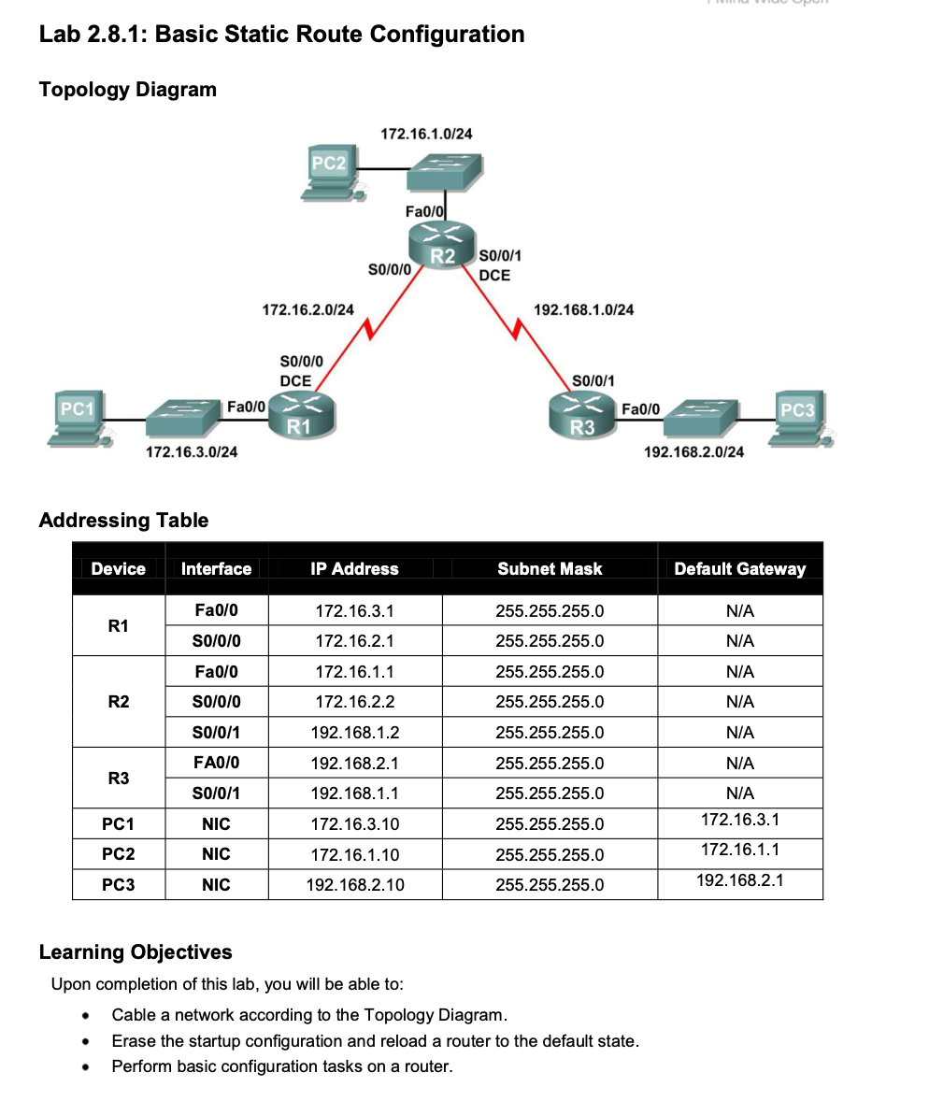

R

Router>en

Router>config t

Enter configuration commands, one per line. End with CNTL/Z.

Router(config)#

Router(config)#interface F0/0

R1

Router(config-if)#ip address 172.16.3.1 255.255.255.0

Router(config-if)#no sh

Router(config)#interface Serial0/0/0

Router(config-if)#ip address 172.16.2.1 255.255.255.0

Router(config-if)#clock rate 64000

Router(config-if)#no sh

R2

Router(config-if)#ip address 172.16.1.1 255.255.255.0

Router(config-if)#no sh

Router(config)#interface Serial0/0/1

Router(config-if)#ip address 172.16.2.2 255.255.255.0

Router(config-if)#no sh

Router(config)#interface Serial0/0/0

Router(config-if)#ip address 192.168.1.2 255.255.255.0

Router(config-if)#clock rate 64000

Router(config-if)#no sh

R3

Router(config-if)#ip address 192.168.2.1 255.255.255.0

Router(config-if)#no sh

Router(config)#interface Serial0/0/1

Router(config-if)#ip address 192.168.1.1 255.255.255.0

Router(config-if)#no sh

Now we have to do Static routing

R3

Router(config)#ip route 172.16.1.0 255.255.255.0 s0/0/0

Router(config)#ip route 192.168.1.0 255.255.255.0 s0/0/0

Router(config)#ip route 192.168.2.0 255.255.255.0 s0/0/0

R2

Router(config)#ip route 172.16.3.0 255.255.255.0 s0/0/1

Router(config)#ip route 192.168.2.0 255.255.255.0 s0/0/0

Router(config)#ip route 172.16.1.0 255.255.255.0 s0/0/1

Router(config)#ip route 172.16.2.0 255.255.255.0 s0/0/1

Router(config)#ip route 172.16.3.0 255.255.255.0 s0/0/1

Ping